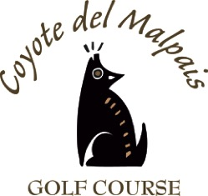

Coyote del Malpais Catering Menu
505-285-5544

Hot Dog Bar $8.00
Hot dogs
Chips
Ketchup
Mustard
Relish
Onion
Jalapeno

Hamburger $10.00
Chips
Ketchup
Mustard
Relish
Onion

Taco Bar (Beef or Chicken) $12.00
2 Tacos per person
Beans
Rice

Assorted Sandwiches $12.00
Chips

Roast Beef Diner $15.00
Mashed Potatoes
Vegetable
Dinner Roll
Gravy

Tapas $ 8.50
Assorted Appetizers
Cheese Sticks
Jalapeno Poppers
Chips and Salsa
Spinach Artichoke Dip
Fried Pickles
Fried Green Beans

Breakfast Bar $8.00
Sausage or Bacon
Eggs
Hash browns
Red or Green Chili

Drinks

Pitchers of soft drinks or tea $5.00
Pot of Coffee $5.00

